Food Delivery Work
A guide for
international students

Participant Handbook

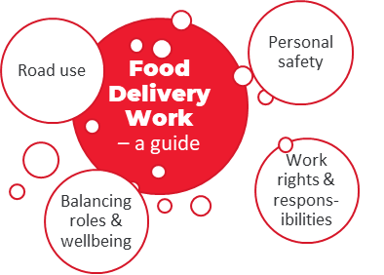

December 2020

Introduction

Welcome to the Food Delivery Work training program. Many international students opt to work in food delivery service as a ‘flexible option’ while studying; but often with limited knowledge of road laws, employee rights and employer responsibilities, which can place them at risk of exploitation or workplace injury due to a lack of local and industry knowledge.

This Participant Handbook forms one part of a training program designed to be facilitated by education providers to ensure that international students in Victoria understand their legal rights and responsibilities for the best possible experience when undertaking this work.
It’s important to note the program is not advocating either for or against this type of work. Instead, it aims to respond to issues affecting international students who choose this type of work to supplement their funds while studying in Australia and provides advice for student’s consideration on the various safety and welfare issues they need to understand to do so as safely and successfully as possible and avoid any common pitfalls experienced.
This program has been developed to support you and looks at issues of welfare and safety in what is a largely unregulated industry area, referencing governing bodies and resources for professional industry standards, laws and legislation where applicable.
Individual decision making, responsibility for your workplace, and seeking legal or industry appropriate advice prior to undertaking any means of work is your responsibility and strongly recommended. Over time laws and regulatory practices will change so you are encouraged to access current information directly from regulatory authorities.
Disclaimer
This project was supported by the Victorian Government and developed to provide educational and workshop content for international students to educate them on work rights, road safety, business and legal rights, particularly around the rising employment area in the gig economy where a seemingly simple activity can generate an income quickly. This information must be understood as introductory only and the greatest benefits can be achieved through a facilitated delivery by support services working in partnership with international students.
Initial workshop content is applicable to Victorian roads and employment standards at the time of original development (August-December 2020). It must be modified for use where appropriate to the laws and industry standards in other States and Territories of Australia.
It is the responsibility of any user of these materials to ensure all content is correct at time of use.
_{Supported by:} _{Project partners:}
December 2020
Contents
Workshop introduction 4
Module 1 – You as a road user 5
Activity 1.1 – Road Safety 7
Frequently Asked Questions 8
Module 2 – Your personal safety 9
Activity 2.1 – Personal safety (fatigue) 12
GLOSSARY 13
Frequently Asked Questions 13
Module 3 – Work rights and responsibilities 15
Activity 3.1 – Work rights & responsibilities 17
Frequently Asked Questions 18
Module 4 – Balancing roles and wellbeing 20
Activity 4.1 – What’s up? 22
Frequently Asked Questions 23

Workshop introduction

PARTICIPANT HANDBOOK
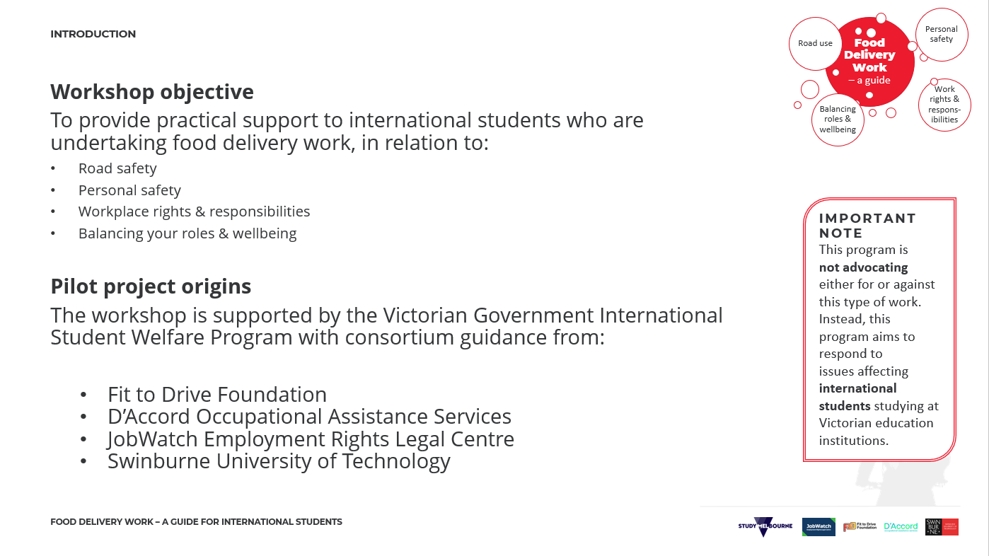

Module 1 – You as a road user

PARTICIPANT HANDBOOK
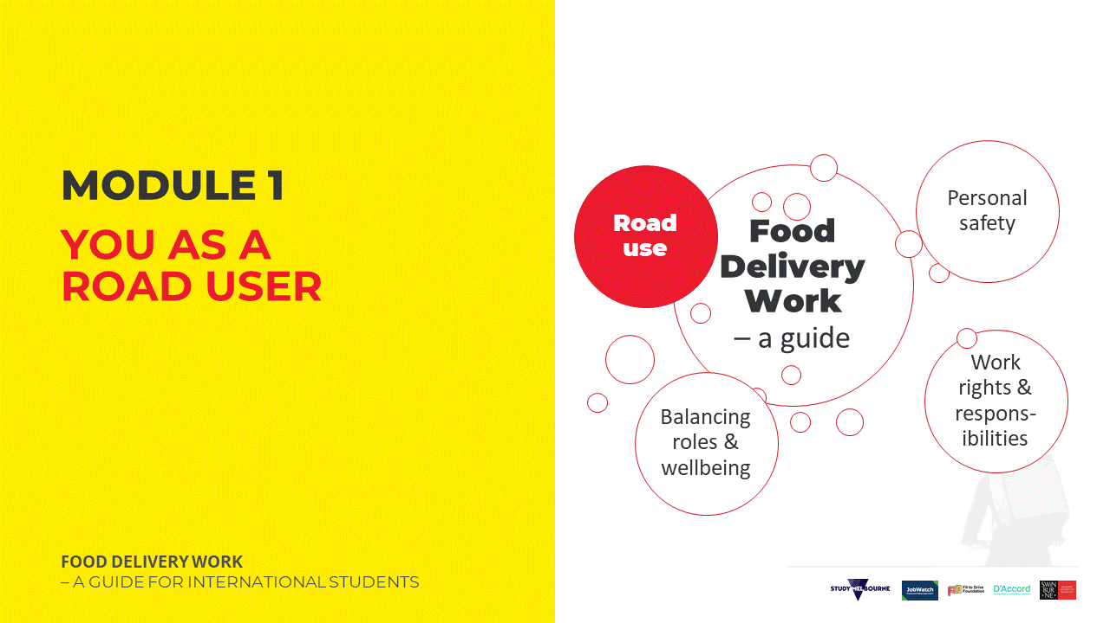 | 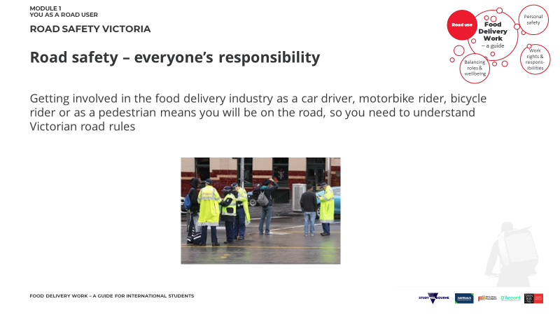
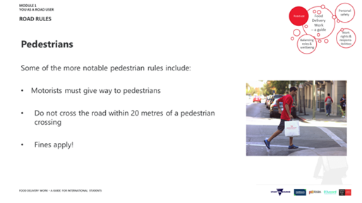 | 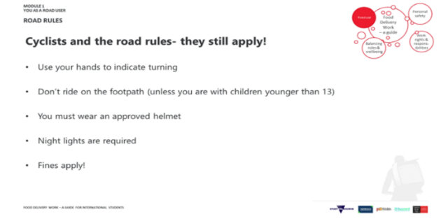
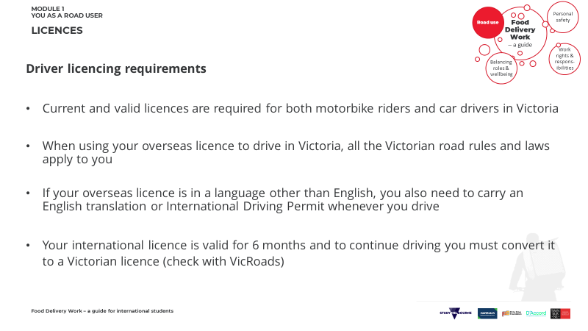 | 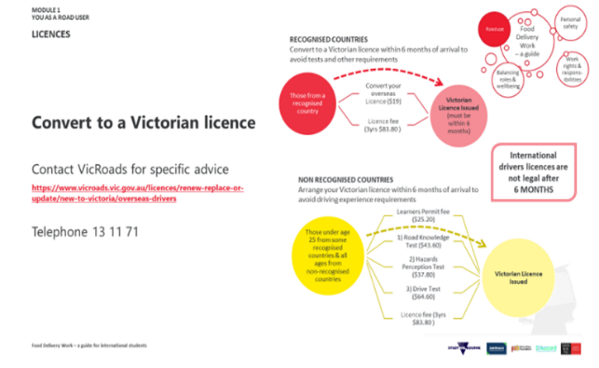
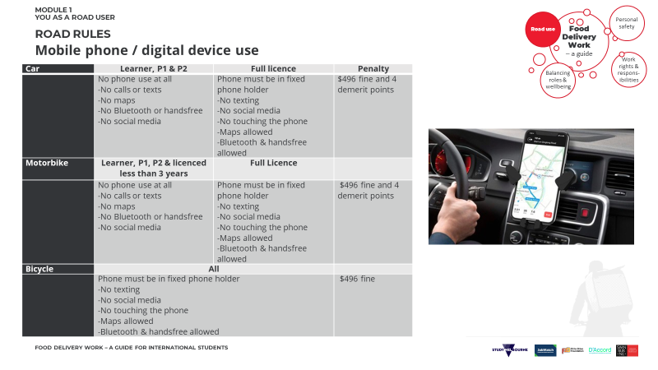 | MY NOTES & ACTION ITEMS:
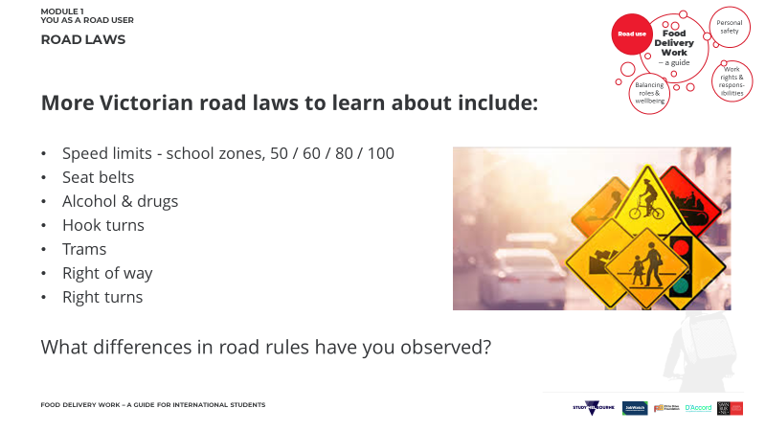 | 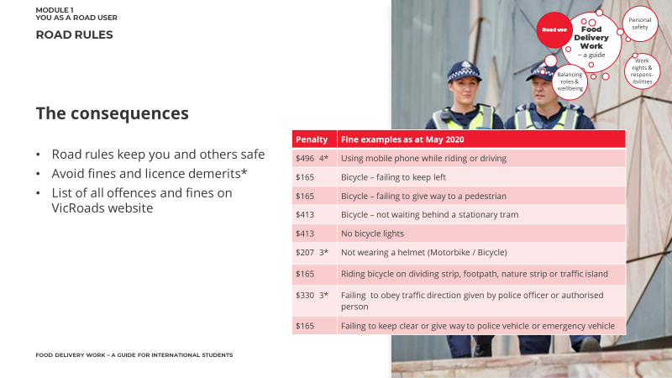
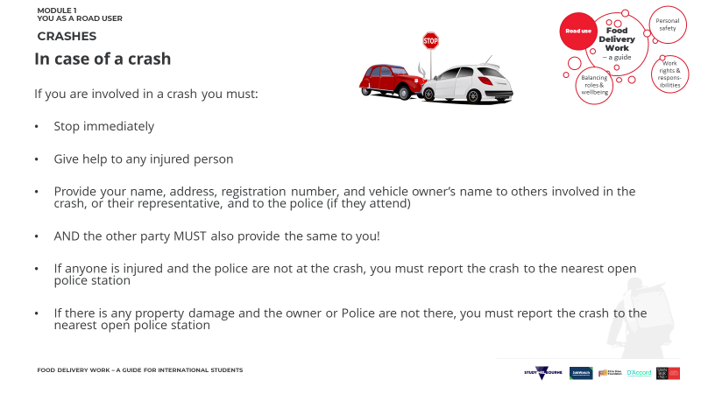 | 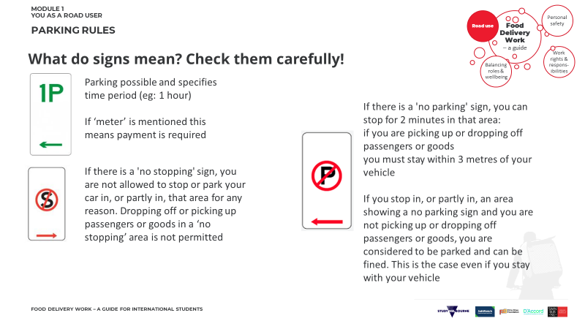
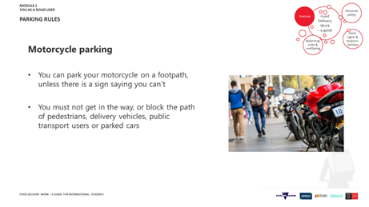 | 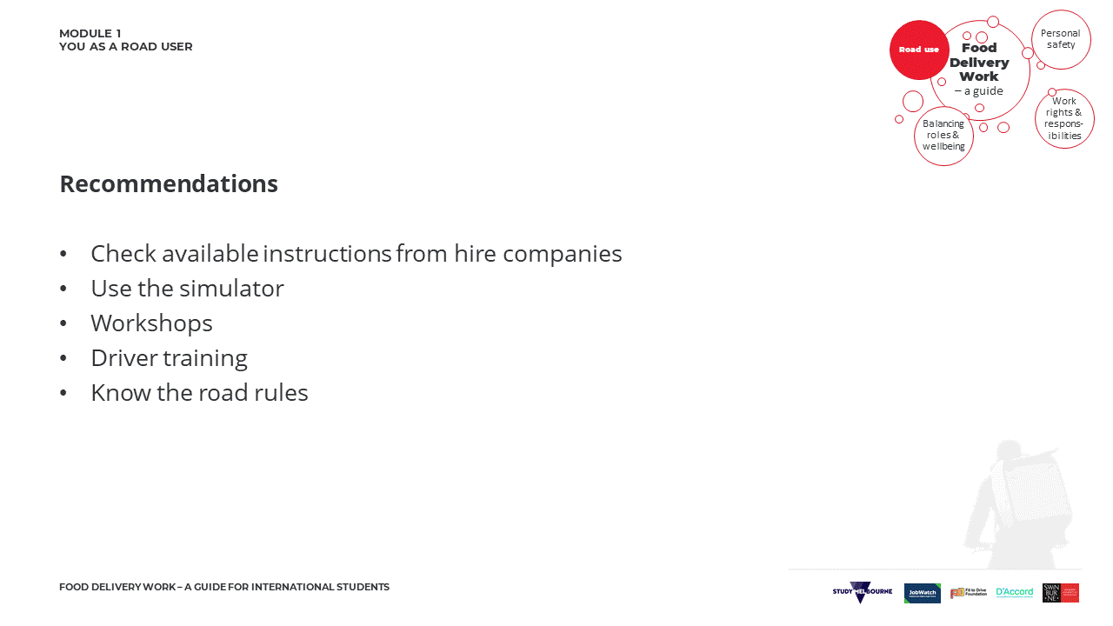
MY NOTES & ACTION ITEMS:

Activity 1.1 – Road Safety  This urban street is a 60km/h zone.  It’s midday.  The weather is clear.  You’re riding a motorbike.  Your speed is 60km/h  This example is from the RideReady simulator.  DISCUSSION  - Describe the scene above.  - What risks can you see?  - What could happen next?  - What precautions would you take? | 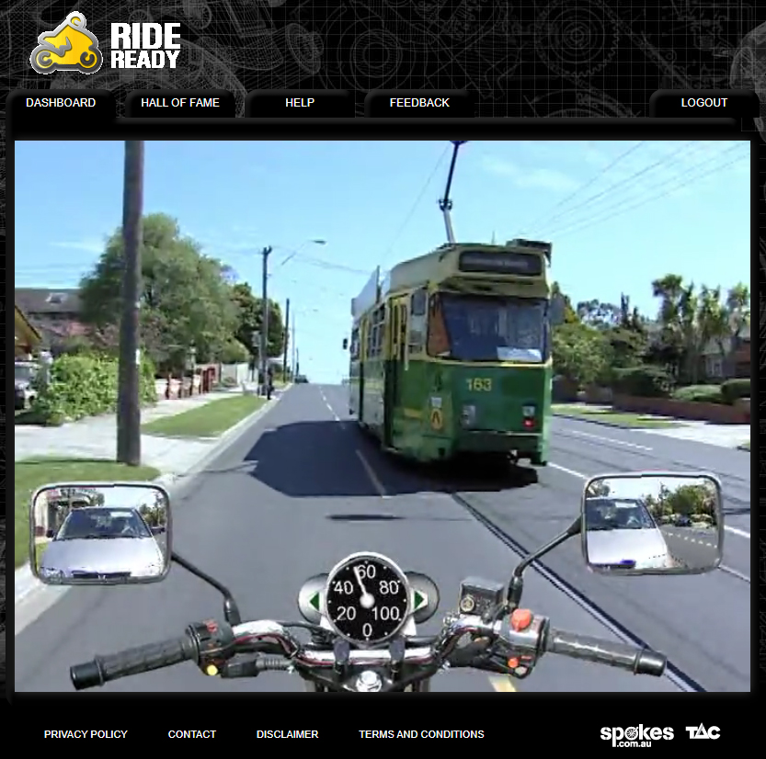
UNDERPINNING KNOWLEDGE | Observe  - What is the speed limit here?  - Who has right of way?  - What could happen next?
RECOMMENDATIONS | WHAT I LEARNED FROM THIS EXERCISE

PARTICIPANT HANDBOOK
RESOURCES

ROAD RULES
Further detail on the road rules relating to pedestrians is provided on the VicRoads website, along with information on pedestrian safety and specific fines for pedestrians. Further common road rules here, Vic Roads YouTube channel, here and here. Further detail on the road rules relating to bike riders is provided here.

MOBILE PHONE USAGE
You can find this resources from Vic Roads on mobile phone use while driving here. You can find this resource from Vic Roads on mobile phone use while driving a motorbike here. You can find this resources from Vic Roads on mobile phone use while on a bicycle here.

IN CASE OF AN ACCIDENT
You can find more about this here.

Frequently Asked Questions

What are the rules for using my phone or other device while driving?
Looking at or touching your mobile phone or electronic device while driving can be extremely dangerous, distracting and is an offence. You must ensure that your vehicle is parked off the road and turned off in order to use your mobile phone or electronic device. If you have a Learner’s Permit or Probationary licence, you must not be using a mobile phone/electronic device/GPS at all, even on hands-free.

What if my licence is from a non-recognised country?
If your licence is not from any of the recognised countries (see VicRoads), you must have your licence verified and complete the relevant tests.

Which part of the road should I travel in on a motorcycle?
If you are driving a motorcycle you must be using the main road and not travelling in the bicycle lane which is to the left of the main road. Bicycle lanes are only intend for bicycles, (this includes power assisted bicycles, see more info here).

What do I do when travelling near/behind a tram?
- You can only overtake a tram on the left.
- You must not drive past the tram when it is stopped at a tram stop, lights are flashing, and passengers are getting on/off. You may only proceed when tram doors are closed, and lights have stopped flashing.

What about specific road laws for pedestrians?
A pedestrian is someone that is either travelling on foot, a skateboard, rollerblades, in a wheelchair or motorized mobility device. Pedestrians are not allowed to cross a pedestrian crossing when facing a red or orange traffic light or cross the road within 20 metres of a pedestrian crossing. It is also an offence for a pedestrian to cross a railway level crossing when a train is coming/boom gates are down.

Module 2 – Your personal safety

PARTICIPANT HANDBOOK
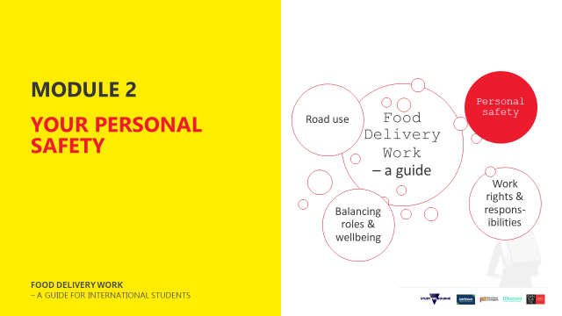 | 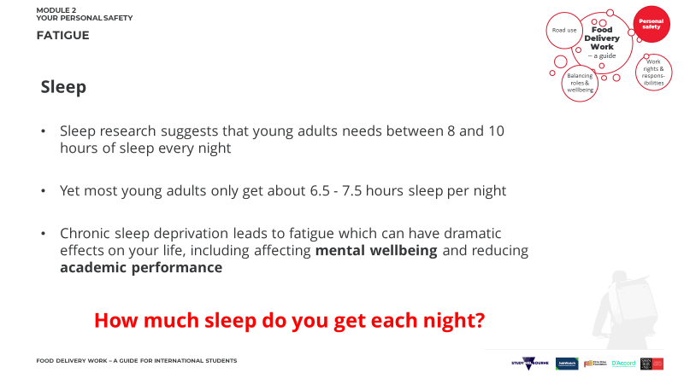
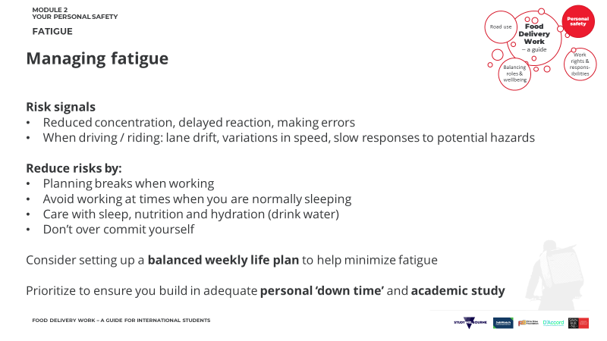 | 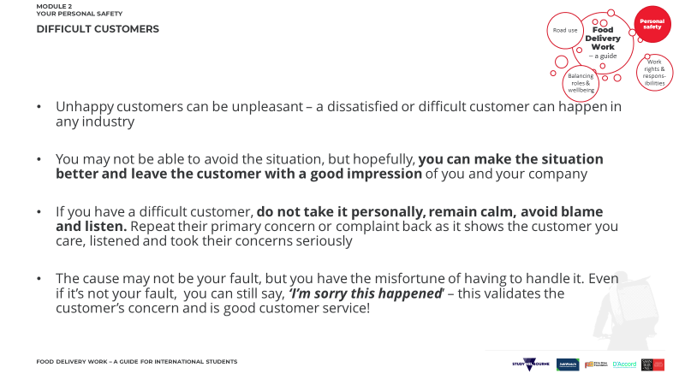
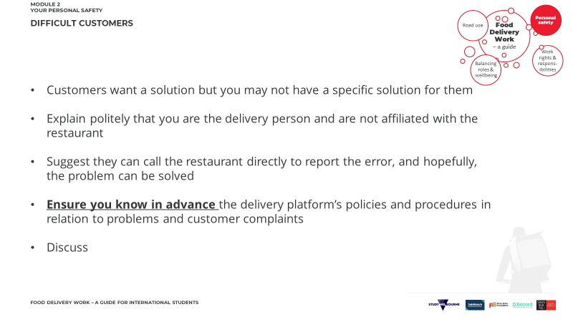 | 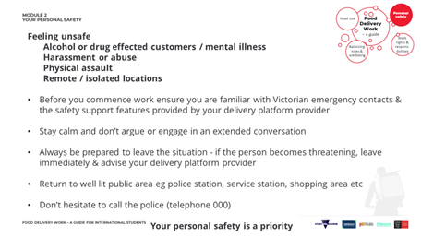
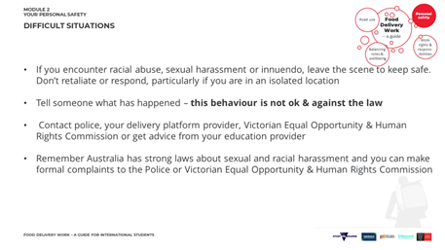 | 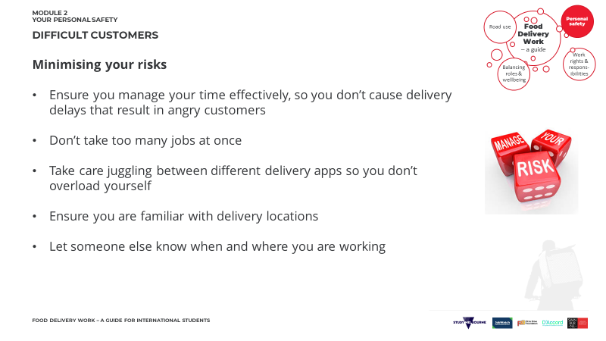
MY NOTES & ACTION ITEMS:

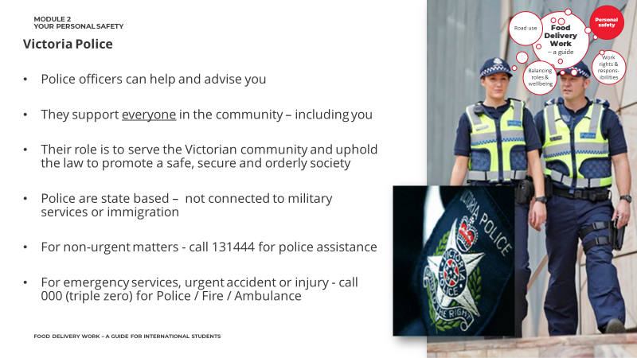 | MY NOTES & ACTION ITEMS:
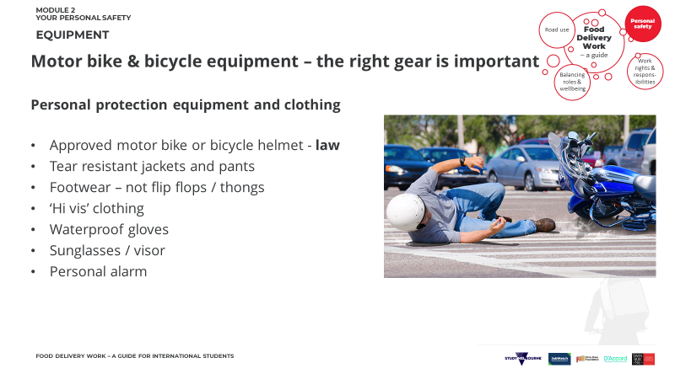 | 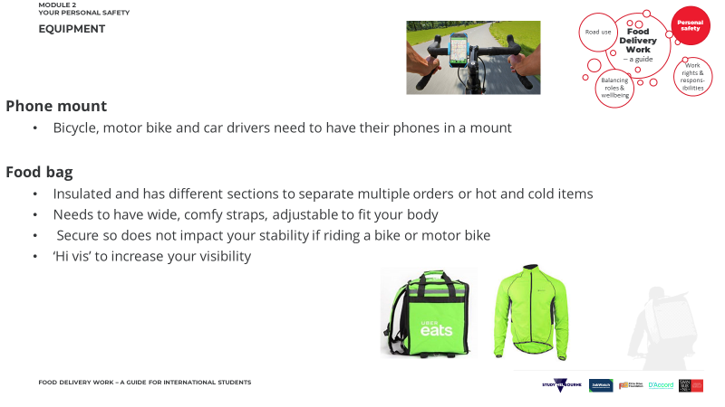
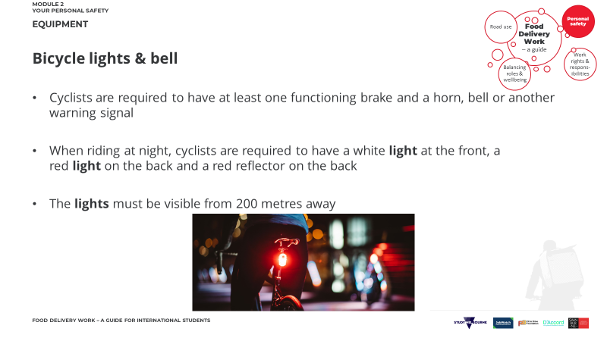 | 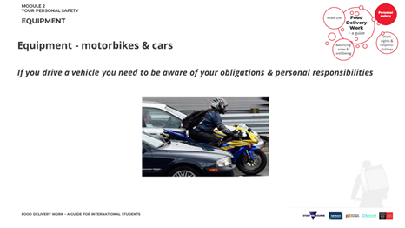
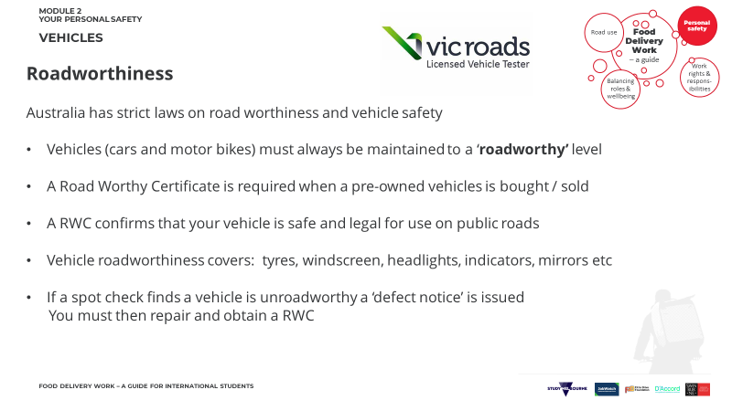 | 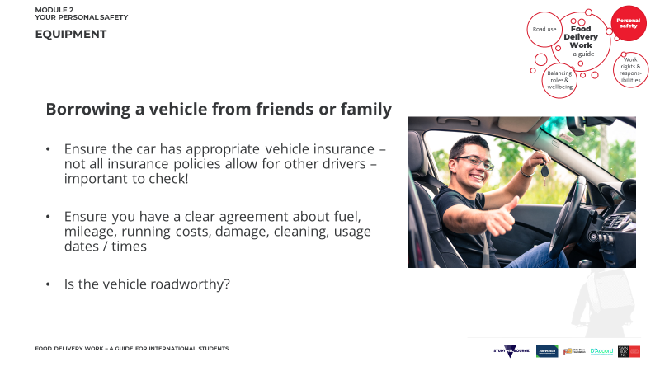
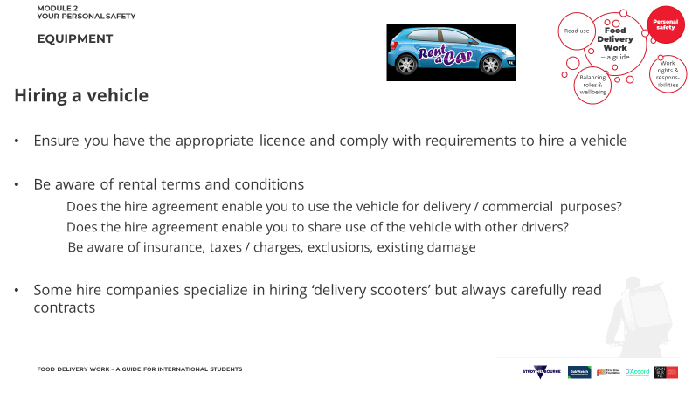 | 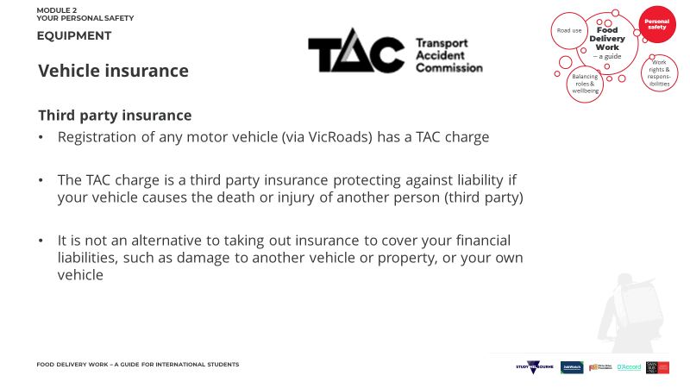
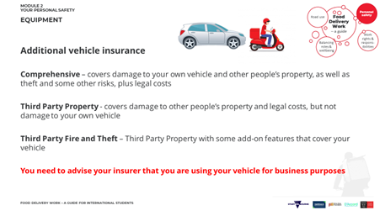 | 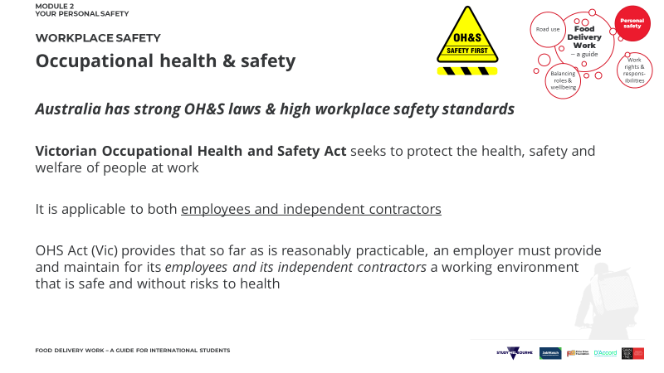
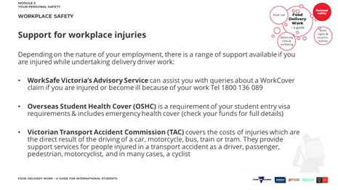 | 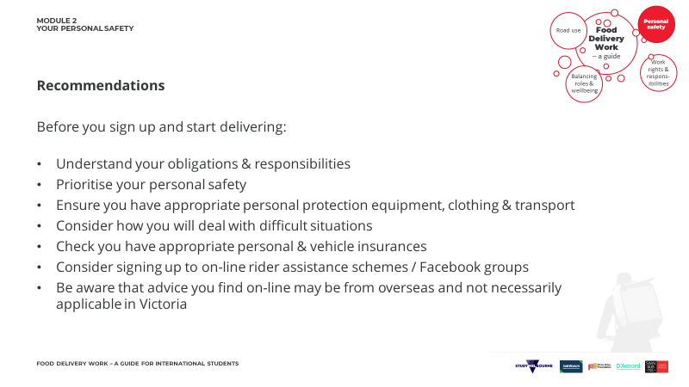
MY NOTES & ACTION ITEMS:

Activity 2.1 – Personal safety (fatigue)
It’s 11pm on Friday night in Hawthorn. It has been raining on and off since you started work at 4pm.
Jobs have been slow and just as you decided to go home a job comes in. It’s 3km away in location that where you have never been before.
You’ve been up since 7am when you helped a friend move into their new flat, before attending lectures and a tutorial.
- Identify any personal safety risks / hazards
- Precautions / preventative measures

In your group identify any safety risks /hazards and precautions /preventative measures.
Risks | Solution / Precaution
UNDERPINNING KNOWLEDGE
- Fatigue – waking hours, length of shift
- Weather – clothing, road conditions
- Night time – reduced visibility, reflective clothing
- Traffic – slippery road surface, visibility
- Equipment – maps, lights, slips falls, tyre tread, personal alarm

PARTICIPANT HANDBOOK
RESOURCES

SLEEP
Most young adults report getting only 6.5-7.5 hours per night. More info here.

DIFFICULT CUSTOMERS
More info and useful tips here. You can find some useful additional resources on racial abuse from the Australian Human Rights Commission here and from Reach Out here.

REGISTRATION
Registration costs can differ depending on location and type of vehicle. You can have a look at this resource from Vic Roads here.

INSURANCE
The Insurance Council of Australia provides a range of advice on appropriate insurance coverage here

GLOSSARY

Occupational Health & Safety is concerned with protecting the safety, health and welfare of people engaged in work or employment. Workers should be able to carry out their responsibilities in a safe and secure working environment, free from hazards.

Roadworthy Certificate A Certificate of Roadworthiness (also known as a 'roadworthy' or 'RWC') shows that your vehicle's safe enough to be used on public roads. A roadworthy is required whenever a vehicle is sold, if it is being re-registered, and to clear some defect notices.

Frequently Asked Questions

If I feel unsafe making deliveries, what should I do?
Return to a public area and call the Police on 000 (triple zero). The Police will then provide guidance.
If you are concerned about negative experiences when making deliveries, reach out to student advisors at your education provider for further support.

What equipment do I need before making bicycle or motor bike deliveries?
Mandatory Equipment | Recommended Equipment
Approved helmet (for bicycles & motor bikes) | Phone mount  *care with use of phone – see module 1 for applicable road laws
Functioning bell on bicycle | Robust footwear
Functioning brake on bicycle | Hi visibility, tear resistant clothing
Lights visible from 200m for night deliveries on bicycle (white font / red back) | Food bag
Motor bike is in roadworthy condition | Personal alarm

What do I do if I am injured making food deliveries?
First priority is your personal safety and wellbeing, so depending on the severity of your injury you may need to contact Victorian emergency providers by calling 000 (triple zero) or make a medical appointment using your Overseas Student Health Cover.
Always advise your education provider as they will have support services available to you.

Other useful contacts:
- WorkSafe Victoria Advisory Service
- Victorian Transport Accident Commission

Module 3 – Work rights and responsibilities
PARTICIPANT HANDBOOK
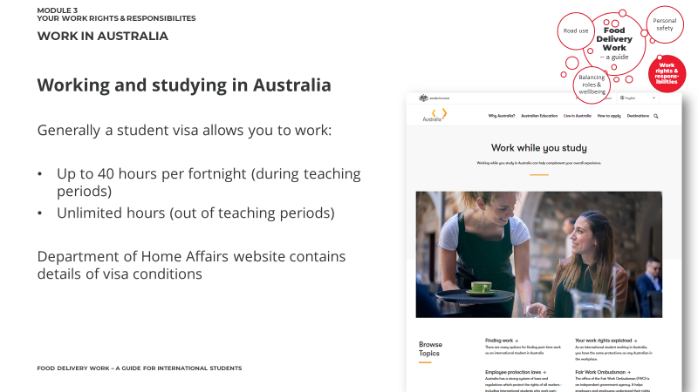 | 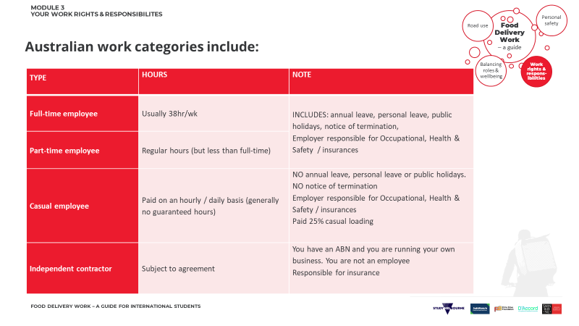
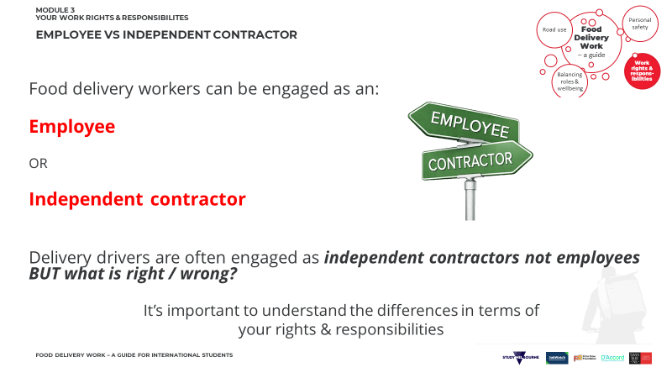 | 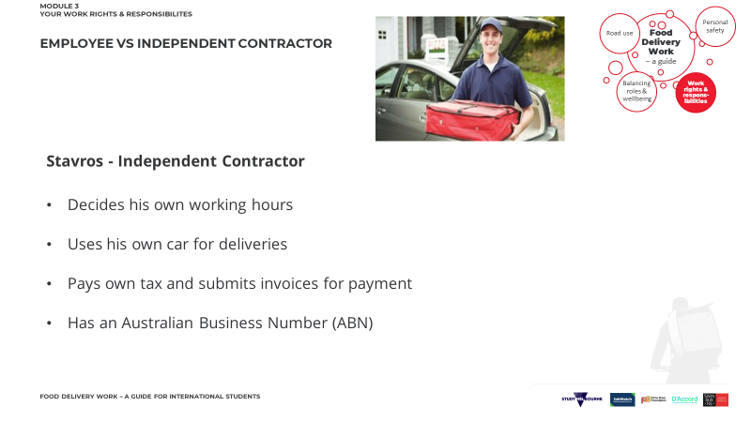
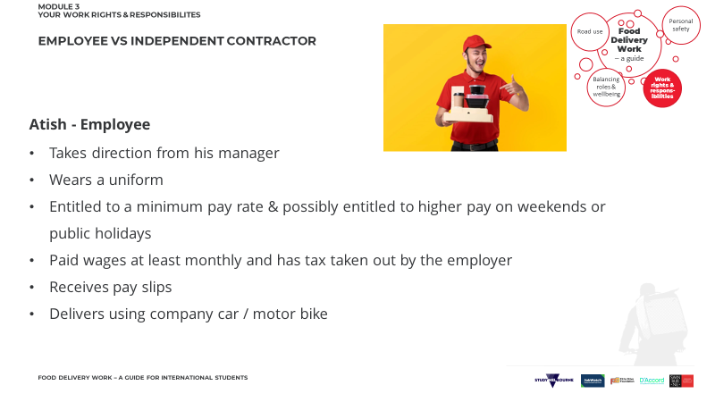 | 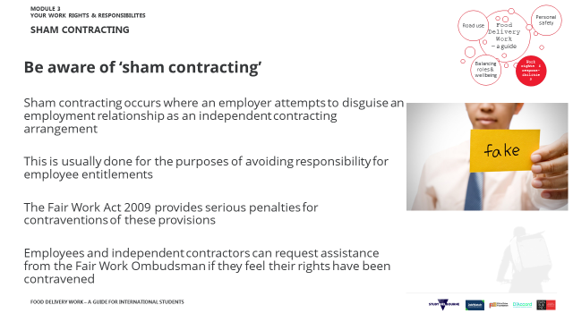
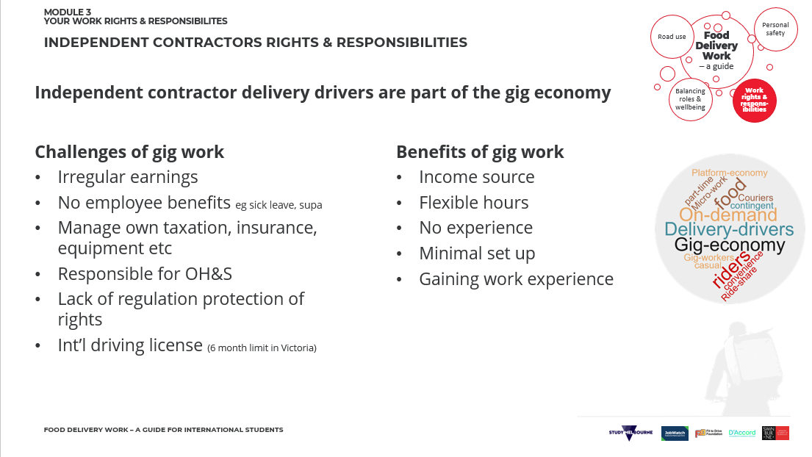
MY NOTES & ACTION ITEMS:

 | 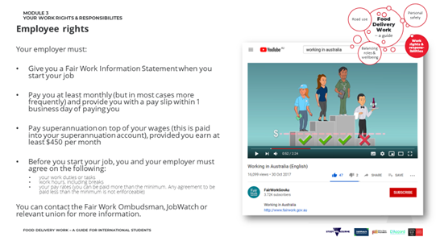
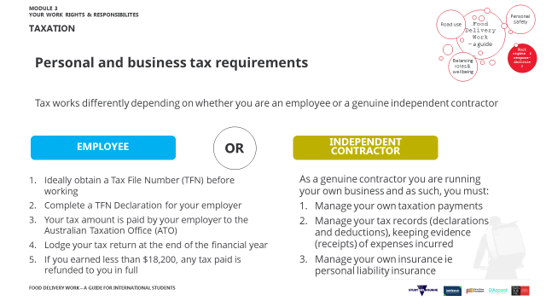 | 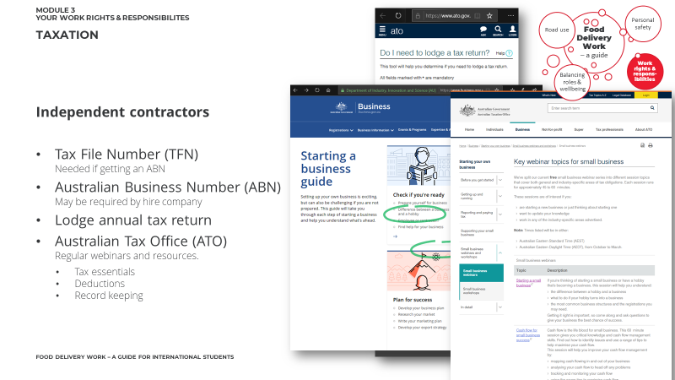
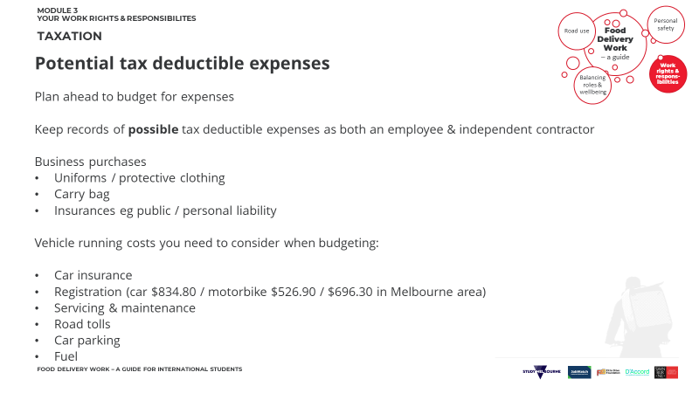 | 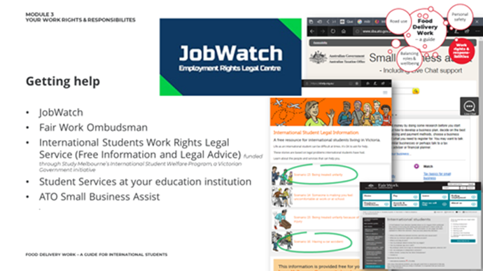
MY NOTES & ACTION ITEMS:

Activity 3.1 – Work rights & responsibilities

Is Jerry an employee or a contractor?

How do you know?

What are the implications? eg tax, ABN, hours etc
Issue | Solution

PARTICIPANT HANDBOOK
RESOURCES

WORKING WHILE STUDYING
Study Australia provides useful information working while you study here.

SHAM CONTRACTING
Fair Work Ombudsman explains this in more detail here.

TAX
Have a look at this resource from Study Melbourne and the ATO.

WHERE TO GET HELP
If you think something is not right with work practices, you can contact JobWatch, Fair Work Ombudsman, International Students Work Rights Legal Service

GLOSSARY

Australian Business Number (ABN) is a unique 11-digit number that identifies a business to the government and community. It is a used for invoicing and taxation etc. More details here

Tax File Number (TFN) is a personal reference for tax and superannuation. More details here

Australian Tax Office (ATO) is responsible for administering the Australian federal taxation system

Frequently Asked Questions

Is there a minimum rate of pay in Australia?
All permanent (full or part time) employees aged 21 and over must be paid a minimum of $19.84* per hour with casual staff receiving 25% extra. Apprentices and trainees (and those under 21) get less. For more specific guidance check the Fair Work Ombudsman FWO’s online pay calculator to see what the minimum pay is for each particular job – many Awards have a higher minimum hourly rate and there are potentially other rates of pay according to time / day worked. (*Rate correct as of 1 July 2020 with reviews usually occurring each July.)
More information on minimum wages here

Does this apply to food delivery workers?
It depends on your work arrangement. If you are employed as an ‘independent contractor’ then this rate does not apply, and you would be subject to arrangements with the delivery platform provider.
If you are employee $19.84 per hour is the minimum amount payable for people aged 21 plus (see above for more detail).

What is the difference between an employee and an independent contractor?
Independent contractors have different obligations and rights to employees because they are running their own business. This means it’s important to understand the difference between the two.
There are several things that can help you tell the difference between an employee and a contractor. There isn’t one that makes a difference on its own – you need to consider everything together.
For more detail on the differences, the Fair Work Ombudsman has a useful fact sheet.

What are my business responsibilities as an independent contractor?
Some of your responsibilities include:
- bearing the risk of making a profit or a loss and usually responsible for poor work or injury
- usually have your own insurance
- use your own tools and equipment
- pay your own tax
- have an ABN and submits invoices

You can find out more about independent contractors here.

Module 4 – Balancing roles and wellbeing
PARTICIPANT HANDBOOK
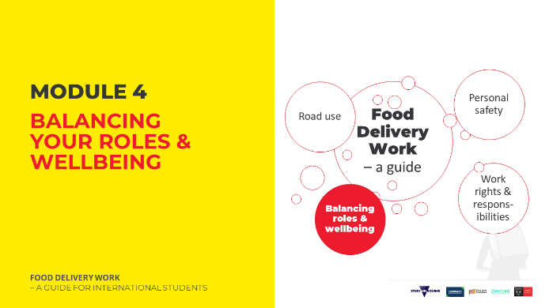 | MY NOTES & ACTION ITEMS:
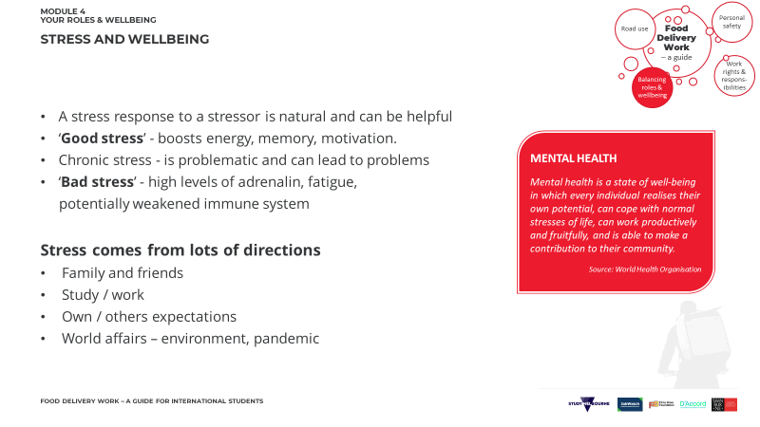 | 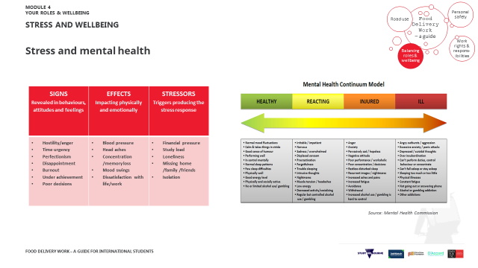
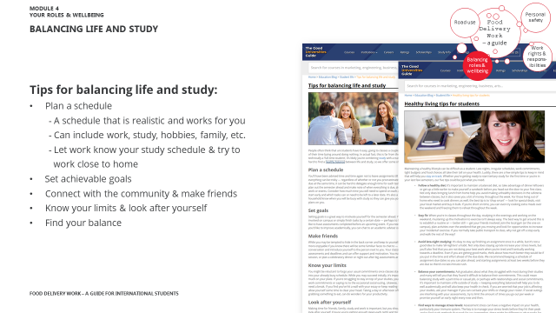 | 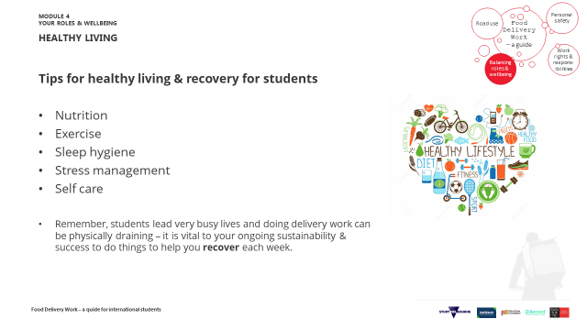
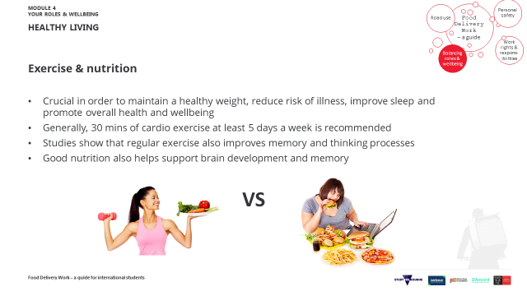 | 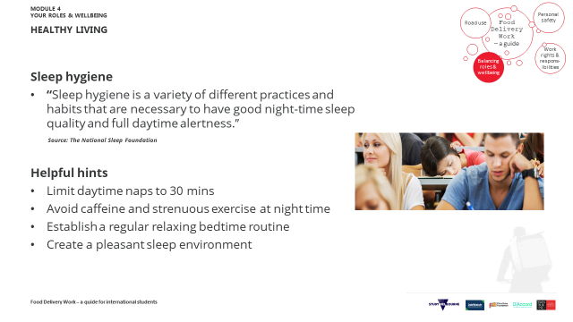
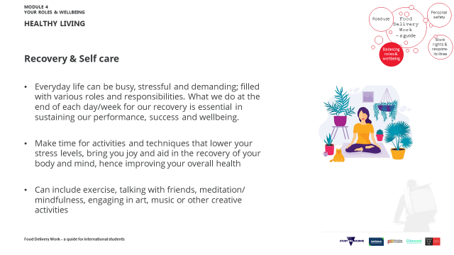 | 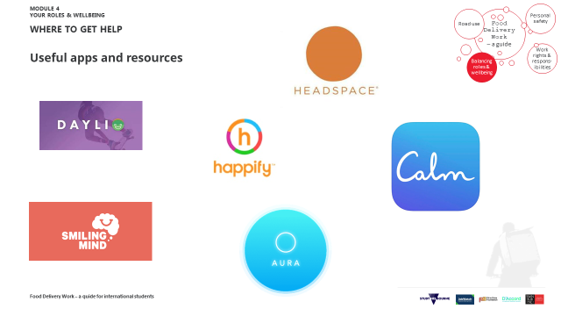
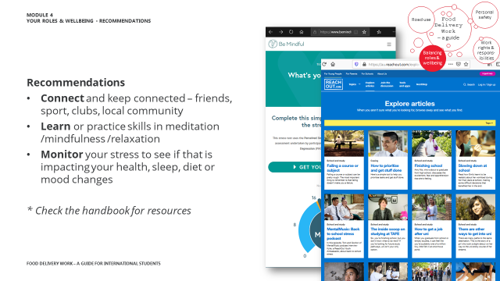 | MY QUESTIONS TO THE PRESENTER:
MY NOTES & ACTION ITEMS:

Activity 4.1 – What’s up?

- Mohammad is a second-year student and his friends are worried about him.
- He has not been to soccer training for weeks. Rumours are he is thinking of withdrawing from his course.
- Jerry, his friend from uni, called all his friends together to check what to do.
TASK
What would you do?

What help is available?

Training disclaimer
These materials are intended to assist international students with their understanding of their rights and responsibilities in relation to food delivery work in Victoria.
The materials aim to provide an introduction to topics and it is not possible to address all topics and responsibilities that students need to be aware of in a presentation of this nature. Thus, this information must be understood as an introductory in nature.
Over time there will be modifications to laws and practices so both trainers and students should be encouraged to access information directly from regulatory bodies.
December 2020

PARTICIPANT HANDBOOK
RESOURCES

BALANCING LIFE AND STUDY
You can check out this useful resource on balancing life and study here.

MANAGING STRESS
Learn skills in meditation /mindfulness /relaxation /communication here.
Have a look at this resource here on monitoring your stress and you can find an anxiety checklist exercise here and a stress test here.

GLOSSARY:

Mental Health Continuum: This is a spectrum with mental healthiness and mental illness on opposite ends. This can be dependent on internal and external factors in the person’s life and the position can change on the spectrum as the person’s mental health improves or worsens. Find more here.

Mindfulness: This is the concept of bringing your full attention to the present moment, fully aware of your surroundings, thoughts and feelings, free from any distraction or judgment. Find more about mindfulness here.

Frequently Asked Questions

How much exercise should I be getting per week?
About 150 mins of moderate or 75 mins of intense aerobic exercise per week.
What is sleep hygiene?
Sleep hygiene is a set of habits that assist you to get a consistent restful night’s sleep.
What are the benefits of meditation?
Addresses stress, reduce depression and anxiety, pain and other health issues.

